***The Third Sunday after Pentecost***

***June 29, 2025***

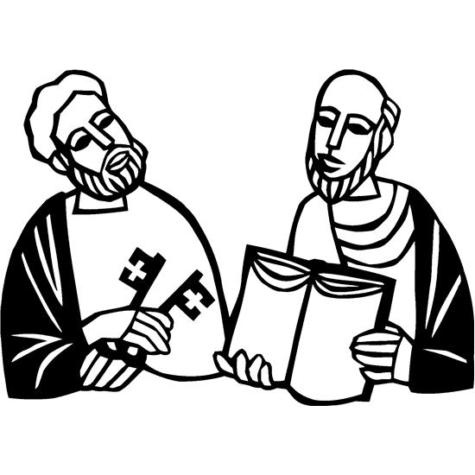

***Lutheran Church of the Good Shepherd***

***383 Old North Rd.***

***Kingston, RI 02881***

***Reverend Dennis Kohl, Pastor***

***Heather Skidds, Minister of Music***

***Welcome to Our Visitors***

In our busy world, we thank God for many things, especially your presence here. We consider it a blessing to have you among us as we gather together as people of God!

We love having guests (and celebrating your return as friends) and want to make sure you always feel welcomed.   If you’re part of another community, we look forward to hearing all about it, and we look forward to welcoming you back when you can visit again!

Sunday is a time to unplug from our busy, distracted lives, and turn back to our God.  Our worship service offers God’s gifts of Liturgy (the order of worship), God’s Word (through Scripture and Sermon), Prayer, and the Sacrament of Holy Communion.

**We are** **a “Reconciling in Christ” church of the ELCA**.  It means that we affirm + accept all people regardless of age, race, ethnicity, legal status, economic situation, sexual orientation, gender identity, marital status, physical or emotional conditions, and whatever else we didn’t list here.  **We believe that God creates us ALL in the image of God, and loves us unconditionally,** and helps us to do the same with everyone.  **We also believe** God desires that everyone should have the opportunity to participate in the life and worship of a faith community.  **We’re glad you’re here!**

**Assistants for today-** **Assisting Minister -** Karen Amitrano

**Lector**- Marie Bender Lee

**Greeter/Ushers**- Kris Bacon

**Communion Assistant**- Annie Senerchia

**Altar set up**- Kris Bacon

**Acolyte-** Anika Baum

**Assistants for next Sunday-** **A****ssisting Minister-**

**Lector**-

**Greeter/Ushers**-

**Communion Assistant**-

**Altar set up**- Mayme & George Morrison

**Acolyte-**

**+GATHERING+  
Prelude-** You Are All We Have, by Francis O’Brien

***stand***

**CONFESSION AND FORGIVENESS**

In the name of the Father,

and of the ☩ Son,

and of the Holy Spirit. **Amen.**

Baptized into Christ, let us confess our sin.

*Silence is kept for reflection.*

Merciful God,

**you free us to love others,**

**but we neglect our neighbors and follow our own way.**

**You lead us by the Spirit of joy and peace,**

**but we turn away from the abundant life you offer.**

**You surround us with patience, kindness,**

**and generosity,**

**but we grow weary in doing what is right.**

**In your mercy, forgive us.**

**Do not give up on us.**

**Heal us, break our bonds,**

**and show us the path of life. Amen.**

You belong to Christ Jesus

and you are God’s children through faith.

In the cross of ☩ Christ,

and through the power of the Holy Spirit,

your sins are forgiven.

Clothed with Christ, you are a new creation. **Amen.**

**Greeting**

The grace of our Lord Jesus Christ, the love of God,

and the communion of the Holy Spirit be with you all.

**And also with you.**

**Gathering Hymn- *ELW 798 Will You Come and Follow Me***

The Lord be with you. **And also with you.**

**PRAYER OF THE DAY** Let us pray:Almighty God, **we praise you that your blessed apostles Peter and Paul glorified you by their martyrdoms. Grant that your church throughout the world may always be instructed by their teaching and example, be knit together in unity by your Spirit, and ever stand firm upon the one foundation who is Jesus Christ our Lord, for he lives and reigns with you and the Holy Spirit, one God, now and forever. Amen.**

**+WORD+**

### *Sit***First Reading: Acts 12:1-11**

1 About that time King Herod laid violent hands upon some who belonged to the church. 2 He had James, the brother of John, killed with the sword. 3 After he saw that it pleased the Jews, he proceeded to arrest Peter also. (This was during the festival of Unleavened Bread.) 4 When he had seized him, he put him in prison and handed him over to four squads of soldiers to guard him, intending to bring him out to the people after the Passover. 5 While Peter was kept in prison, the church prayed fervently to God for him.  
  6 The very night before Herod was going to bring him out, Peter, bound with two chains, was sleeping between two soldiers, while guards in front of the door were keeping watch over the prison. 7 Suddenly an angel of the Lord appeared and a light shone in the cell. He tapped Peter on the side and woke him, saying, “Get up quickly.” And the chains fell off his wrists. 8 The angel said to him, “Fasten your belt and put on your sandals.” He did so. Then he said to him, “Wrap your cloak around you and follow me.” 9 Peter went out and followed him; he did not realize that what was happening with the angel’s help was real; he thought he was seeing a vision. 10 After they had passed the first and the second guard, they came before the iron gate leading into the city. It opened for them of its own accord, and they went outside and walked along a lane, when suddenly the angel left him. 11 Then Peter came to himself and said, “Now I am sure that the Lord has sent his angel and rescued me from the hands of Herod and from all that the Jewish people were expecting.”

### Word of God, Word of Life.  **Thanks be to God.**

**Psalm: Psalm 87:1-3, 5-7** *to be sung*

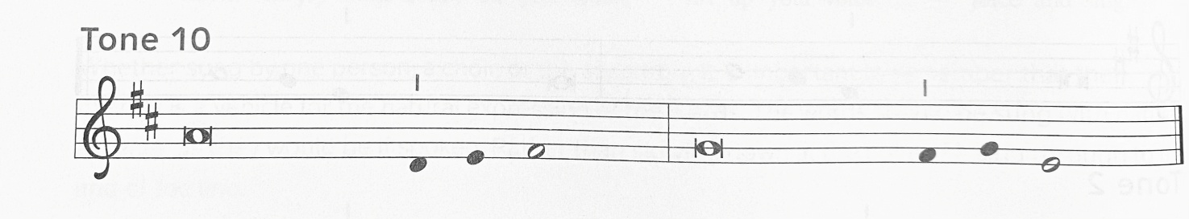

1 On the **|** holy mountain  
  stands the city **|** God has founded;  
 2 **the Lord loves the | gates of Zion**  
  **more than all the dwell- | ings of Jacob.**  
 3 Glorious things are spo- **|** ken of you,  
  O city **|** of our God.  
 5 **Of the city it shall be said, “Everyone was | born in Zion,**  
  **and the Most High shall sus- | tain the city.”**  
 6 Enrolling the nations, the **|** Lord records:  
  “These al- **|** so were born there.”  
 7 **The singers and the danc- | ers will say,**  
  **“All my fresh springs | are in you.”**

**Amen**

**Second Reading: 2 Timothy 4:6-8, 17-18**

6 As for me, I am already being poured out as a libation, and the time of my departure has come. 7 I have fought the good fight, I have finished the race, I have kept the faith. 8 From now on there is reserved for me the crown of righteousness, which the Lord, the righteous judge, will give me on that day, and not only to me but also to all who have longed for his appearing.  
  17 But the Lord stood by me and gave me strength, so that through me the message might be fully proclaimed and all the Gentiles might hear it. So I was rescued from the lion’s mouth. 18 The Lord will rescue me from every evil attack and save me for his heavenly kingdom. To him be the glory forever and ever. Amen. Word of God. Word of Life. **Thanks be to God.**

*Stand*

**Gospel Acclamation**

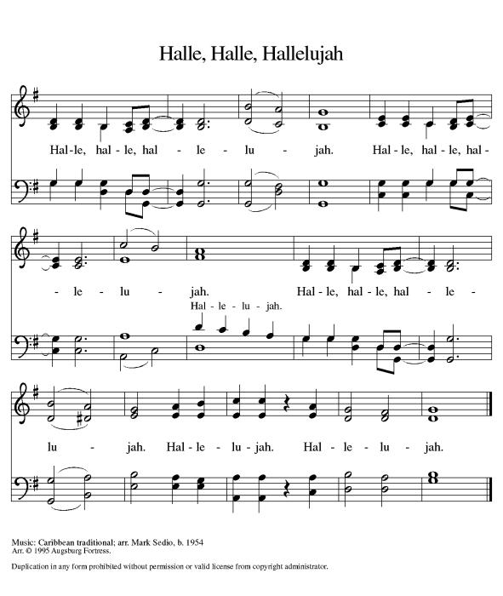 **Gospel: John 21:15-19**

The holy Gospel according to John

**Glory to you, O Lord.**

**Gospel: John 21:15-19**

15 When they had finished breakfast, Jesus said to Simon Peter, “Simon son of John, do you love me more than these?” He said to him, “Yes, Lord; you know that I love you.” Jesus said to him, “Feed my lambs.” 16 A second time he said to him, “Simon son of John, do you love me?” He said to him, “Yes, Lord; you know that I love you.” Jesus said to him, “Tend my sheep.” 17 He said to him the third time, “Simon son of John, do you love me?” Peter felt hurt because he said to him the third time, “Do you love me?” And he said to him, “Lord, you know everything; you know that I love you.” Jesus said to him, “Feed my sheep. 18 Very truly, I tell you, when you were younger, you used to fasten your own belt and to go wherever you wished. But when you grow old, you will stretch out your hands, and someone else will fasten a belt around you and take you where you do not wish to go.” 19 (He said this to indicate the kind of death by which he would glorify God.) After this he said to him, “Follow me.”

The Gospel of our Lord.  
**Praise to you, O Christ.**

*Sit***SERMON**

*Stand*Hymn of the Day.

**Apostles Creed***Baptized into Christ, with the whole Church, let us confess our faith.*

**I believe in God, the Father almighty,**

**creator of heaven and earth.**

**I believe in Jesus Christ, God’s only Son, our Lord,**

**who was conceived by the Holy Spirit,**

**born of the virgin Mary,**

**suffered under Pontius Pilate,**

**was crucified, died, and was buried;**

**he descended to the dead.**

**On the third day he rose again;**

**he ascended into heaven,**

**he is seated at the right hand of the Father,**

**and he will come to judge the living and the dead.**

**I believe in the Holy Spirit,**

**the holy catholic church,**

**the communion of saints,**

**the forgiveness of sins,**

**the resurrection of the body,**

**and the life everlasting. Amen.**

**PRAYERS OF INTERCESSION  
AM:** Each petition concludes God of grace, **hear our prayer.**

*The pastor concludes the prayers*Gather all our prayers in your mercy, O God, through Jesus Christ, our Savior.

**Amen.**

**PEACE**

The peace of Christ be with you.  **And also with you.***A sign of peace and reconciliation is shared among worshippers.*

*SIT*

**Musical Offering- *I Will Follow You***

*Our offering is presented for the work of the church locally and throughout the world.*

*Stand*

**Offering Prayer** AM: Let us pray: Creator God, **in your wisdom you bring forth all that is good and the harvest is plentiful. Strengthen us at your table with these gifts of the earth and our labor, that we may work for the good of all; through Jesus Christ, our Savior. Amen.**

**+MEAL+**

**THE GREAT THANKSGIVING**  
The Lord be with you. And also with you.

Lift up your hearts. **We lift them to the Lord.**

Let us give thanks to the Lord our God.

**It is right to give God thanks and praise**.

*The pastor prays the preface for the congregation.* It is indeed right, our duty and our joy, that we should at all times and in all places give thanks and praise to you, almighty and merciful God, through our Savior Jesus Christ.  You reveal your glory as  the glory of the Father, the Son, and the Holy Spirit: equal in Majesty, undivided in splendor, one Lord, one God, ever to be adored in your eternal glory.  And so, with all the choirs of angels, with the church on earth and the hosts of heaven, we praise your name and join their unending hymn:

**Sanctus**

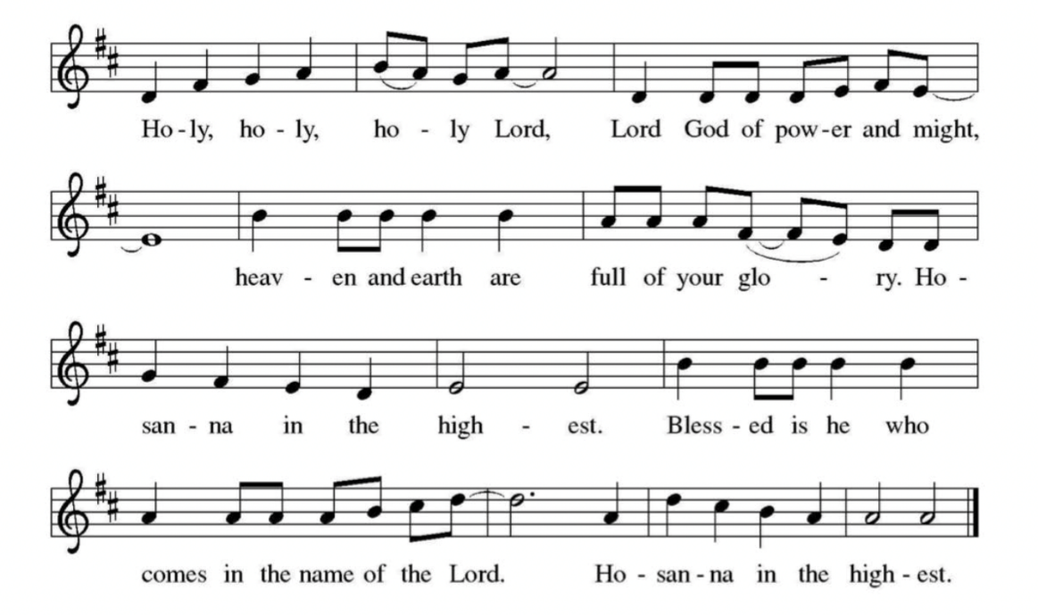

*The pastor and congregation pray the Thanksgiving at the Table.*Holy God, our Maker, Redeemer, and Healer… we await that day when

Jesus will return and make us whole. **Amen. Come, Lord Jesus**

**….** That all may be fed with your Son, the bread of life. **Amen. Come, Holy**

**Spirit**

…Through him all glory and honor is yours, Almighty Father, with the

Holy Spirit, in your holy Church, both now and forever. **Amen.**

Gathered into one by the holy spirit, let us pray as Jesus taught us.  
**Our Father...**

**Invitation to communion:**

The kingdom of God is set before you. Eat and rejoice.

*Please remain standing until the Angus Dei is sung*

**Agnus Dei** Donna Gilton



Lamb of Go-d, You take a-way the si-ns, sins of the world. Have



*Sit***Distribution of Holy Communion***Our congregation practices eucharistic hospitality.  We believe that the resurrected Christ is truly present in the bread and wine with his gifts of life, forgiveness of sin, and salvation.  All are welcome at the Lord’s table.  Please come to the altar to receive the bread and wine.  If you are wearing a mask, remove it to eat and drink the sacrament.  If you receive the wine, take a small cup, or you may instinct the host in the chalice. Place the small cups in the baskets on either side of the altar area.  Please return to your seat by the side aisles.*

**Communion Reflection: *ELW 574 Here I Am Lord***

**+SENDING+**

*Stand***BLESSING**The body and blood of our Lord Jesus Christ strengthen you and keep you in his grace.  **Amen.**

**PRAYER AFTER COMMUNION**AM: Let us pray: Mothering God, **you gathered us to your table and we drank deeply of your grace. Send us out by your Spirit to love our neighbors as ourselves and proclaim your love in Jesus’ name. Amen.**

**BENEDICTION**The Lord bless you and keep you.

The Lord shine on you with grace and mercy.

The Lord look upon you with favor and + give you peace. **Amen.**

*SIT*

**ANNOUNCEMENTS**

*Stand*

***SENDING HYMN- ELW 624 Jesus Still Lead On***

**Dismissal:**

AM: Go in peace. Live by the Spirit. **Thanks be to God.**

**Postlude-** Andante in C, by Merkel

***Sundays and Seasons v.20220215.1125  
Copyright © Augsburg Fortress. All rights reserved.***

**Announcements**

1. **ELCA WORLD HUNGER APPEAL IN JUNE**
2. Food, clean water, medications, education, disaster response both here and globally. Our donations to Hunger Appeal will help with all of those! Place your gifts in envelopes provided on the tables in the narthex, checks payable to LCGS with World Hunger Appeal on the memo line. The need is great everywhere. Thanks, and Blessings!
3. **Ongoing Prayers for:**
4. *For additions or deletions please e-mail or call the church office.789-7776, or* [*lcgsmail@gmail.com*](mailto:lcgsmail@gmail.com)
5. Kaitie Connors De
6. Linda Barany
7. Ellen Bennett
8. Jocleyn Theroux
9. Mari Dulek
10. Karin Kohl
11. Jessica Maynard
12. Bobbie Peterson
13. C. Duncan
14. Margaret Franks
15. Billy Wernquest
16. Ruth Wernquest
17. Holly Deutsch
18. Mary Jane Briggs
19. Bill Deutsch
20. Gary Durett
21. Natalie Schanck
22. Mike Carty
23. Barbara Smith
24. Phyllis Farley
25. Brian Mitchell
26. Barney
27. Joyce Pearson
28. James Meyers
29. Naomi Sawyer
30. Carolyn Hathaway
31. Betty Hathaway
32. Pat Sweeney
33. Karolyn Lee
34. Liam Varnelis
35. Josh Peterson
36. Kathy Lee
37. Chris Rose
38. Lisa Ferry
39. Ellora Hendrickson
40. Melvin Platt
41. KC Christensen
42. Jan Briggs
43. Ruth McGuy
44. Bud Godwin
45. Lisa Lessman
46. Taylor Lessman
47. Joan & Sheldon Pratt
48. Jerry Paquin
49. Stanley Larson
50. Ellen Hedlund
51. Donald & Bernadine Cunnigen
52. Maggie Reichgott
53. Tucker Maute
54. Karen Perry
55. Mark Quinn
56. Tim Diskin
58. **+LOVED ONES IN THE ARMED FORCES**+ Manny Morales, Michael Bock
59. Matthew Kankash, Heath O’Neill, Andrew Anderson, Noah Cooper, Dan Berkowitz